“SOC Analyst Assistant – Incident RAG Investigation System”

Scenario
You are working in the Security Operations Center (SOC) of a multinational enterprise.
SOC analysts receive hundreds of alerts daily, ranging from failed login attempts to confirmed malware detections.
The organization has accumulated thousands of past security incidents involving:
- brute-force SSH attempts
- encoded PowerShell activity
- malware detections
- suspicious outbound traffic
- credential dumping
- unauthorized RDP
- phishing-induced infections
- VPN misuse
- irregular sudo usage
- ransomware behavior
SOC analysts manually look up similar past incidents to diagnose new alerts.
This is slow and error-prone.
Analysts currently search a large historical incident knowledge base manually every time a new alert comes in.
You must build an LLM + RAG–based Security Incident Assistant to:
- Recommend resolutions
- Retrieve similar past incidents
- Recall analyst-specific preferences across sessions
- Extract important entities (IPs, OS, MITRE tags)
- Provide enriched threat analysis
The assistant loads a file:

security_incidents.txt (200–300 lines)
Each line contains:
- User
- Hostname
- OS
- Source IP
- Alert summary
- MITRE ATT&CK tags
- Severity (Low/Medium/High/Critical)
- Resolution steps
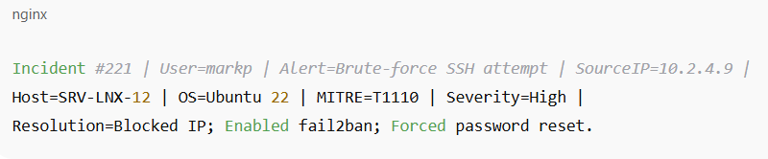

Your Task
Build a console-based SOC RAG Assistant (soc_rag_app.py) using:
- LangChain
- Ollama (Mistral or Llama3)
- LCEL Runnable pipelines
- Hybrid retrieval (FAISS + BM25)
- User-specific memory (InMemoryChatMessageHistory)
- Entity memory extraction
The script runs:
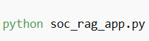
Console asks:
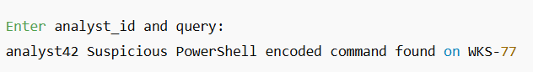
Output must include:
- Retrieved context from RAG
- Injected user memory
- Injected entity memory (OS/IP/MITRE)
- Final LLM answer
- Optional: tool-based resolution

Functional Requirements (Base 40 Marks)

1. Load the Dataset
- Load security_incidents.txt
- Show count and sample
- Convert each incident into Document format

2. Chunking
- Use RecursiveCharacterTextSplitter
- Chunk size ~300–500 chars with overlap
- Show #chunks

3. Embeddings + FAISS Vector Store
- Build FAISS index
- Create vector retriever (k=4)

4. Bonus: Hybrid Retrieval (10 Marks)
Create:
- BM25 retriever
- Ensemble retriever with weights:
  - Vector: 0.7
  - BM25: 0.3
This improves exact term matching (IPs/hosts).

5. LCEL RAG Chain
Build chain:

Prompt must include:
- Retrieved context
- Entity memory (bonus)
- Analyst history
- Query

6. Memory (10 Marks)
Implement:
RunnableWithMessageHistory
Store history per analyst:
store = {
"analyst42": InMemoryChatMessageHistory(...)
}
Inject past conversation into each turn.

Bonus Tasks
Bonus 1: Add a Tool – Threat Enrichment (5 Marks)
Implement a tool:
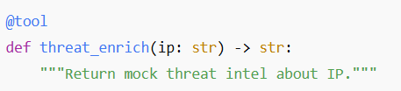
Example output:
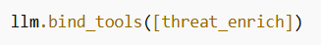

Bonus 2: Entity Memory Extraction (5 Marks)
Implement custom logic to extract entities from:
- query
- retrieved context
Entities must include ANY of the following when present:
- IP addresses
- OS
- Hostname
- MITRE technique code (Txxxx)
- Severity

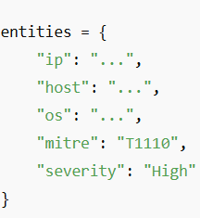

Inject into prompt as:
Bonus 3: Threat Score (5 Marks)
Implement your own scoring logic:
- based on MITRE tag
- severity
- presence of malicious IP
- suspicious PowerShell activity
- brute-force indicators
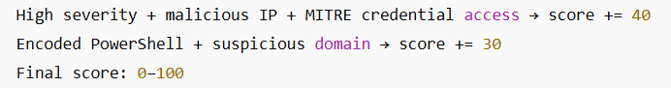
Bonus 4: Structured Output (JSON) (5 Marks)
Convert LLM response to JSON-like dictionary.
